Task 1: Create a VPC with a private subnet and a public subnet

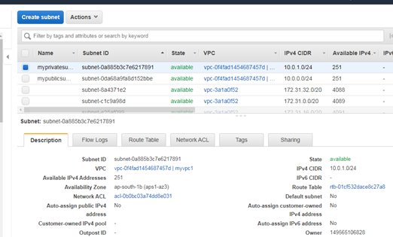

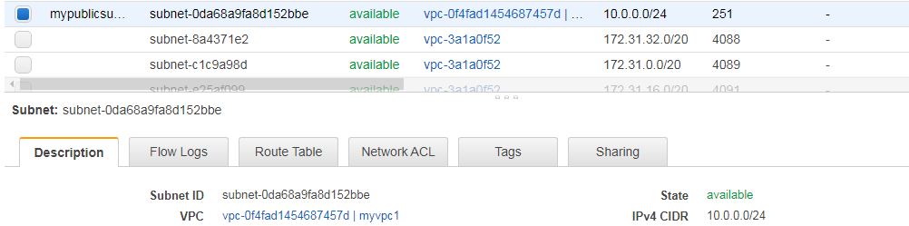

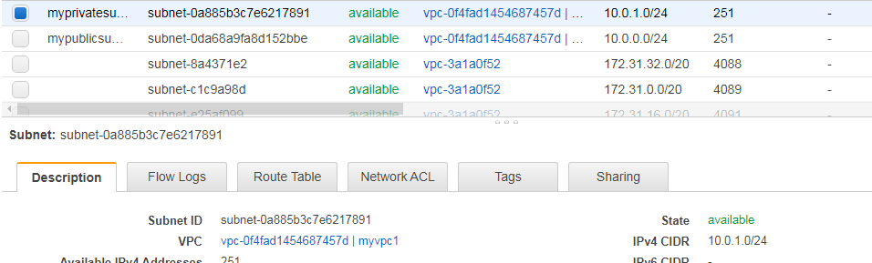

Task2 : Create a igw and associate with the public subnet

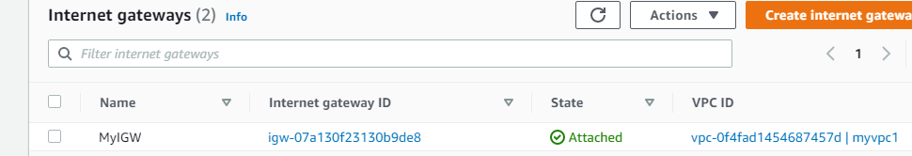

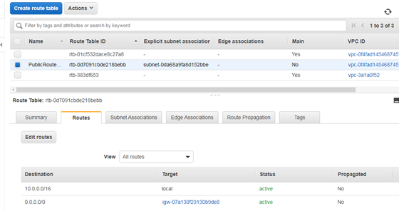

Task3:   
Launch instance->Linux instance->Under configure instance details ->select Network as myvpc1 and Subnet as mypublic subnet which we created->Add storage-> Name, mypublicec2server->Configure SG:Type (ssh,source:anywhere)->Launch

Same we need to launch instance with private subnet->select Network as myvpc1 and Subnet as myprivate subnet which we created->Add storage-> Name, myprivateec2serverConfigure SG:Type (ssh,source:custom(0.0.0../0)->Launch

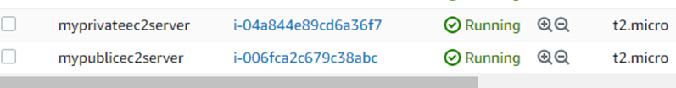

when we tried to connect to the private ec2 instance it will not connect and will show error like no public IPV4 address.

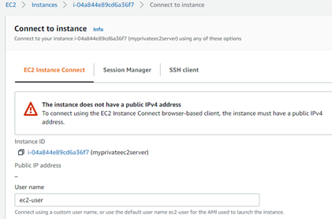

Creating the NAT Gateway

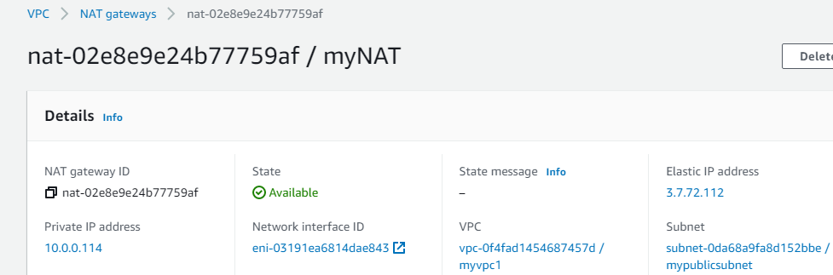

Task4: launch bastion server in the public subnet launch two webservers in the private subnet

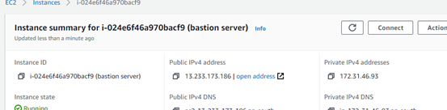

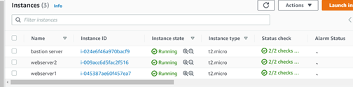

Task5 : Create a load balncer in using the webservers in the public subnet range

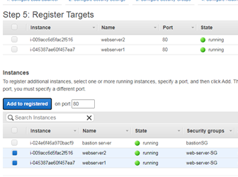

Task6: Install apache tomcat and edit index.html in Webserver1 and 2 throughh the bastion host.

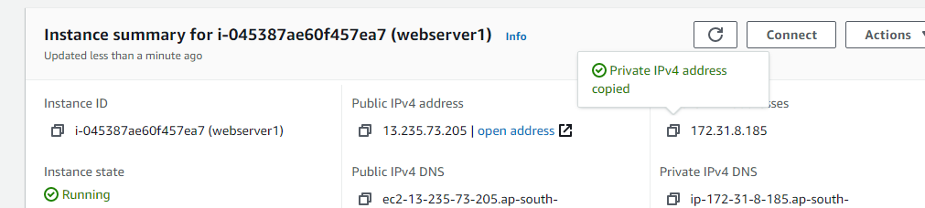

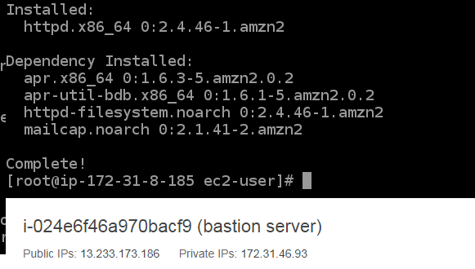

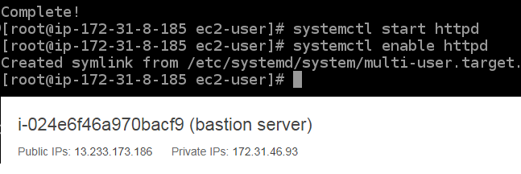

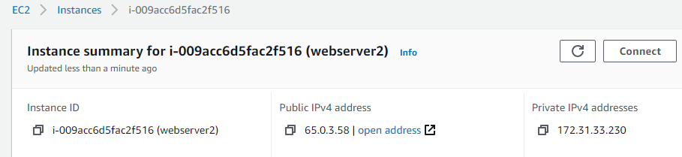

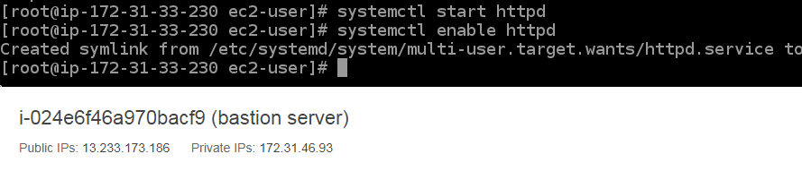

Task7: DNS to check the availability of the application

